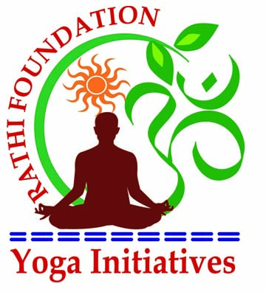
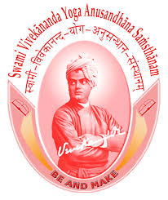
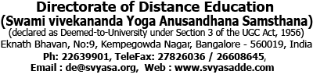

Bachelor of Science (Yoga)
For Office Use
Roll No:
Ref:
Batch : January 2016 July 2016
Name: Dr. / Smt / Sri

Date of Birth : Sex : Male / Female

Marital Status : Single / Married Nationality :

Address :

Postal Code : Country :

Telephone : Mob :

Fax : Email :

Father Name / Guardian :

Educational Qualifications (10th OR High School and above) :
Course Title | University / Institute and Place | Year Of Passing | % of Marks secured

Present Occupation :

Websiter :

- Health Status : Normal [ ] Ailments [ ]
- Ailments, If any :

For Foreign Nationals / NRIs :
i. Passport No.: ii. Date Of Expiry :
iii. Place Of Issue : iv. VISA No.:
v. Valid Upto : vi. VISA Type:

Category (Applicable only for Indians):
SC [ ] ST[ ] Backward Community(BCM)[ ]
Backward Tribe(BCT)[ ] Others[ ]

Service Projects you have participated, if any :

Yoga courses completed, if any :

Extra-Curricular Activities :

Subjects of interest :

Any other information you wish to give in support of your application (Attach separate sheets)
Write 20-sentence note describing reasons for joining this course (Attach separate sheets)
I have gone through the prospectus and instruction. I hereby agree to abide by all the rules and regulations of DDE,S-VYASA. All Information provided here in is true to the best of my knowledge.
Date: Place: Signature of Candidate:
Documents to be submitted along with application:
(Please note: Yoga Instructor’s Course PLUS ANY Graduation are prerequisites)
- Tow Passport Size Photographs (Six For Non-Indians)
- Attested Marks card from High School(10th Standard) to highest examination passed.
- Attested Copies of University Certificates.
- Copy of Passport and Visa (for non-Indian Nationals)
- Health / Fitness Certificate.

